|  |  |  |  |  |
| --- | --- | --- | --- | --- |
|  |  | | |  |
| **Check_MK Plug-in**  **V2.0.1** | | |
| **User Guide** | | |
| **Issue** | **01** | |
| **Date** | **2020-11-23** | |
|  | | | | |
|  | HUAWEI TECHNOLOGIES CO., LTD. | |  |  |

|  |
| --- |
| **Copyright © Huawei Technologies Co., Ltd. 2020. All rights reserved.**  No part of this document may be reproduced or transmitted in any form or by any means without prior written consent of Huawei Technologies Co., Ltd.  **Trademarks and Permissions**  and other Huawei trademarks are trademarks of Huawei Technologies Co., Ltd.  All other trademarks and trade names mentioned in this document are the property of their respective holders.  **Notice**  The purchased products, services and features are stipulated by the contract made between Huawei and the customer. All or part of the products, services and features described in this document may not be within the purchase scope or the usage scope. Unless otherwise specified in the contract, all statements, information, and recommendations in this document are provided "AS IS" without warranties, guarantees or representations of any kind, either express or implied.  The information in this document is subject to change without notice. Every effort has been made in the preparation of this document to ensure accuracy of the contents, but all statements, information, and recommendations in this document do not constitute a warranty of any kind, express or implied. |

|  |  |
| --- | --- |
| Huawei Technologies Co., Ltd. | |
| Address: | Huawei Industrial Base  Bantian, Longgang  Shenzhen 518129  People's Republic of China |
| Website: | <https://e.huawei.com> |
|  |  |

Preface

Purpose

This document describes how to install and uninstall the Check_MK plug-in, add and delete Huawei servers, and view Huawei server information and status.

Intended Audience

This document is intended for:

* Technical support engineers
* System maintenance engineers

Symbol Conventions

The symbols that may be found in this document are defined as follows.

| Symbol | Description |
| --- | --- |
|  | Indicates an imminently hazardous situation which, if not avoided, will result in death or serious injury. |
|  | Indicates a potentially hazardous situation which, if not avoided, could result in death or serious injury. |
|  | Indicates a potentially hazardous situation which, if not avoided, could result in minor or moderate injury. |
|  | Indicates a potentially hazardous situation which, if not avoided, could result in equipment damage, data loss, performance deterioration, or unanticipated results.  NOTICE is used to address practices not related to personal injury. |
|  | Calls attention to important information, best practices, and tips.  NOTE is used to address information not related to personal injury, equipment damage, and environment deterioration. |

Change History

| Issue | Date | Description |
| --- | --- | --- |
| 01 | 2020-11-23 | This issue is the first official release. |

Contents

Preface ii

1 Overview 1

2 Installing and Uninstalling the Check_MK Plug-in 3

2.1 Preparing for the Installation 3

2.2 Installing the Check_MK Plug-in 4

2.3 Uninstalling the Check_MK Plug-in 4

3 Configuring Huawei Servers 5

3.1 Adding a Huawei Server 5

3.1.1 Adding a Huawei Server Directly 5

3.1.2 Adding a Huawei Server in Folder Mode 10

3.2 Editing a Huawei Server 15

3.2.1 Editing a Directly Added Huawei Server 15

3.2.2 Editing a Huawei Server That Is Added in Folder Mode 18

3.3 Deleting a Huawei Server 21

3.3.1 Deleting a Directly Added Huawei Server 21

3.3.2 Deleting a Huawei Server That Is Added in Folder Mode 22

4 Viewing Huawei Server Information 25

4.1 Viewing Information of a Directly Added Huawei Server 25

4.2 Viewing Information of a Huawei Server That Is Added in Folder Mode 27

5 FAQ 30

5.1 Connection Timeout Is Displayed When You Click Full scan During HMM Monitoring 30

A Getting Help 31

A.1 Collecting Fault Information 31

A.2 Preparing for Debugging 31

A.3 Using Product Documentation 31

A.4 Obtaining Technical Support 31

# Overview

Function Description

The Check_MK plug-in is a plug-in integrated in the Check_MK software and used for Huawei server management. The plug-in can be used to add Huawei servers and monitor them.

You can implement the following functions by using the Check_MK plug-in:

* View the component information of added servers.
* View the alarm information of added servers.

Before using the Check_MK plug-in, you need to install the Check_MK 1.6.

Supported Servers

Table 1-1 lists the servers supported by the Check_MK plug-in.

Supported servers

| Type | Model |
| --- | --- |
| Rack server | RH2288H V2 |
| RH1288 V3 |
| RH2288 V3 |
| RH2288H V3 |
| RH5885 V3 |
| RH8100 V3 |
| 1288H V5 |
| 2288H V5 |
| 2488 V5 |
| Blade server | E9000 |
| High-density server | XH321 V3 |
| XH620 V3 |
| XH622 V3 |
| XH628 V3 |

# Installing and Uninstalling the Check_MK Plug-in

2.1 Preparing for the Installation

2.2 Installing the Check_MK Plug-in

2.3 Uninstalling the Check_MK Plug-in

## Preparing for the Installation

* Check whether Check_MK is installed and whether the Check_MK version is 1.6.
* Download the Check_MK plug-in software package from the [GitHub](https://github.com/Huawei/Server_Management_Plugin_Check_MK/tree/master/releases) website and upload it to the Check_MK server.
* The Python tool version is Python 2.7.13.
* Make sure **snmpget** and **snmpwalk** command can run in you host, if not, run the follow command to install them.

**yum install net-snmp net-snmp-devel net-snmp-libs net-snmp-utils php-snmp**

* The following files exist on the Check_MK server:
* pysnmp-4.2.4.tar.gz
* pyasn1-0.1.6.tar.gz
* pycrypto-2.3.tar.gz



Download the **pysnmp-4.2.4.tar.gz**, **pyasn1-0.1.6.tar.gz**, and **pycrypto-2.3.tar.gz** files and upload them to any directory on the Check_MK server, for example, **/usr/local**) and install the software. The procedure for software installation is as follows:

Run the following command to decompress the software package.

**tar xzvf** *$sourcName*

For example, If **pysnmp-4.2.4.tar.gz** is used as an example, run **tar xzvf pysnmp-4.2.4.tar.gz**.

Run the following command to go to the decompression directory.

**cd**

For example, if **pysnmp-4.2.4.tar.gz** is used as an example, run **cd pysnmp-4.2.4**.

Run the following commadn to install the software:

**python setup.py install**

If the system has multiple python versions, run the **export PATH=***$pythonPath***:$PATH** command, where **$pythonPath** indicates thedirectory where Python 2.7.13 is located.

## Installing the Check_MK Plug-in

Log in to the Check_MK server as user root.

Go to the path of the Check_MK plug-in software package.

Run the following command to decompress the Check_MK plug-in software package:

**tar -xvf Huawei_Check-MK_Plugin_vX.X.tar**

Run the following command to install the Check_MK plug-in.

**python install.py -i prod**

Run the following command to restart the httpd service.

**service httpd restart**

[root@localhost cmkplugin_latest]# service httpd restart   
Redirecting to /bin/systemctl restart httpd.service   
[root@localhost cmkplugin_latest]#

The Check_MK plug-in is installed.

----End

## Uninstalling the Check_MK Plug-in

Log in to the Check_MK server as user root.

Go to the path of the Check_MK plug-in software package.

Run the following command to uninstall the Check_MK plug-in.

**python install.py -u prod**

Run the following command to restart the httpd service.

**service httpd restart**

[root@localhost cmkplugin_latest]# service httpd restart   
Redirecting to /bin/systemctl restart httpd.service   
[root@localhost cmkplugin_latest]#

The Check_MK plug-in is uninstalled.

----End

# Configuring Huawei Servers

3.1 Adding a Huawei Server

3.2 Editing a Huawei Server

3.3 Deleting a Huawei Server

## Adding a Huawei Server

You can add a Huawei server in either of the following ways:

* Add a Huawei server directly: Add a single Huawei server.
* Add a Huawei server in folder mode: In this mode, you need to create a folder and then add servers to the folder.

### Adding a Huawei Server Directly

Prepare a PC that can ping the Check_MK IP address.

Open the browser on the PC, enter **http://***Check_MK IP address***/prod/** in the address box, and press **Enter**.

The page for entering the Check_MK user name and password is displayed, as shown in Figure 3-1.

Entering the Check_MK user name and password

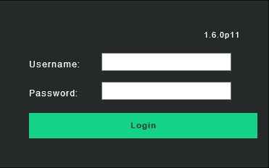

Enter the Check_MK user name and password, and click **Login**.

The Check_MK home page is displayed, as shown in Figure 3-2.

Check_MK home page

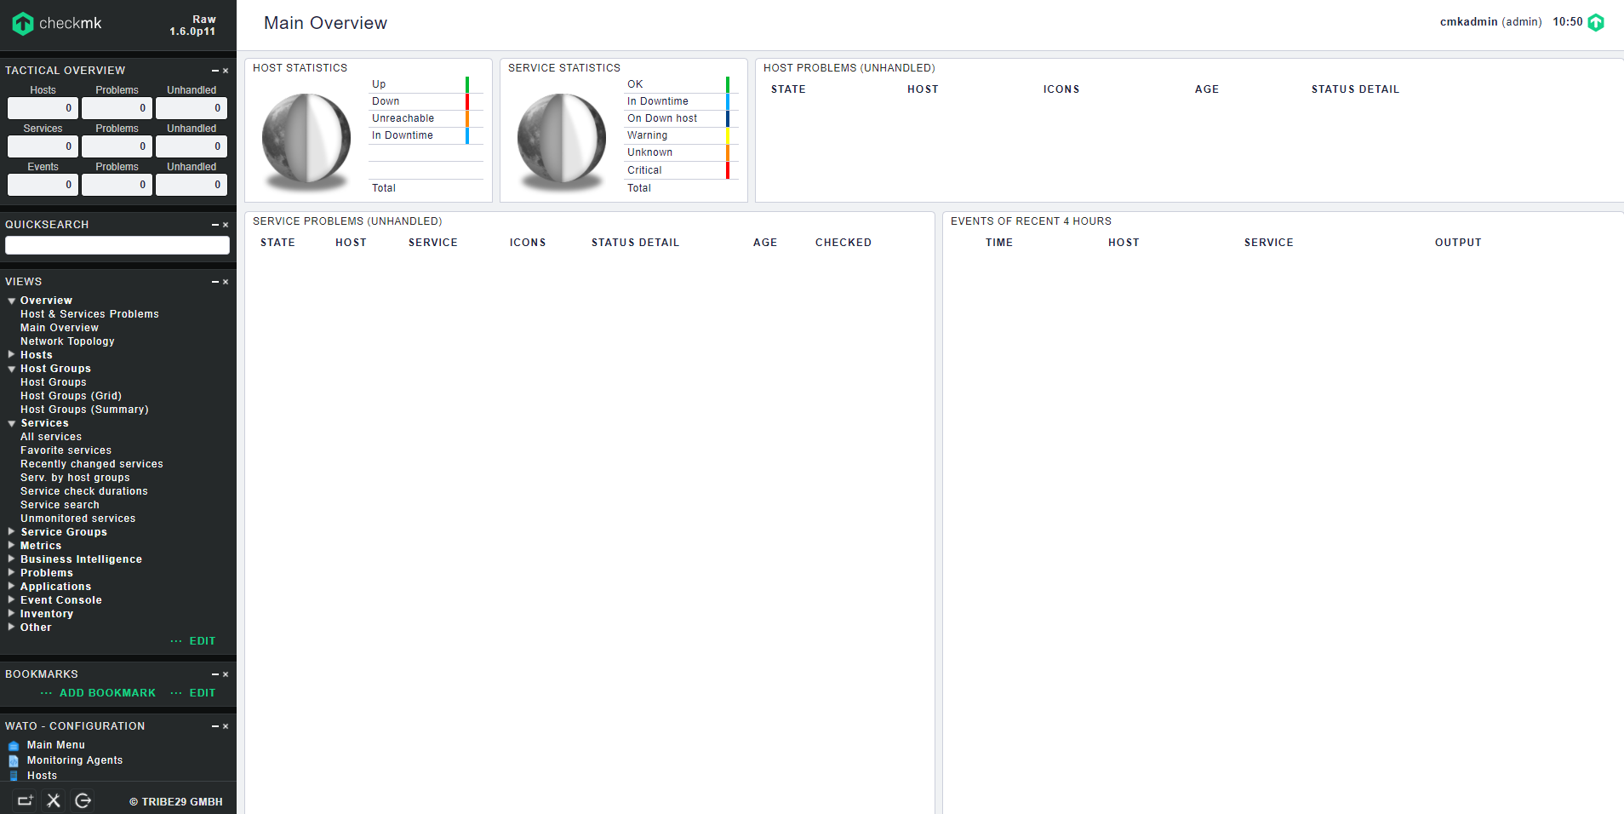

On the menu bar on the left, click **WATO - CONFIGURATION** > **Hosts**.

The **Main directory** page is displayed, as shown in Figure 3-3.

Main directory page

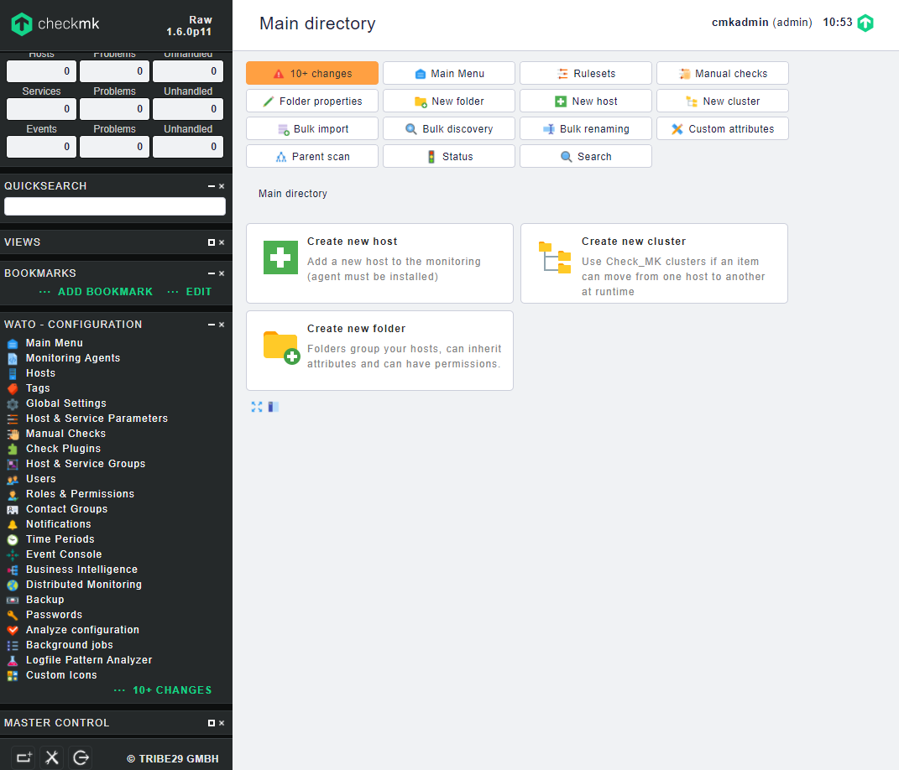

Click **New host**.

The **Create new host** page is displayed, as shown in Figure 3-4.

Create new host page

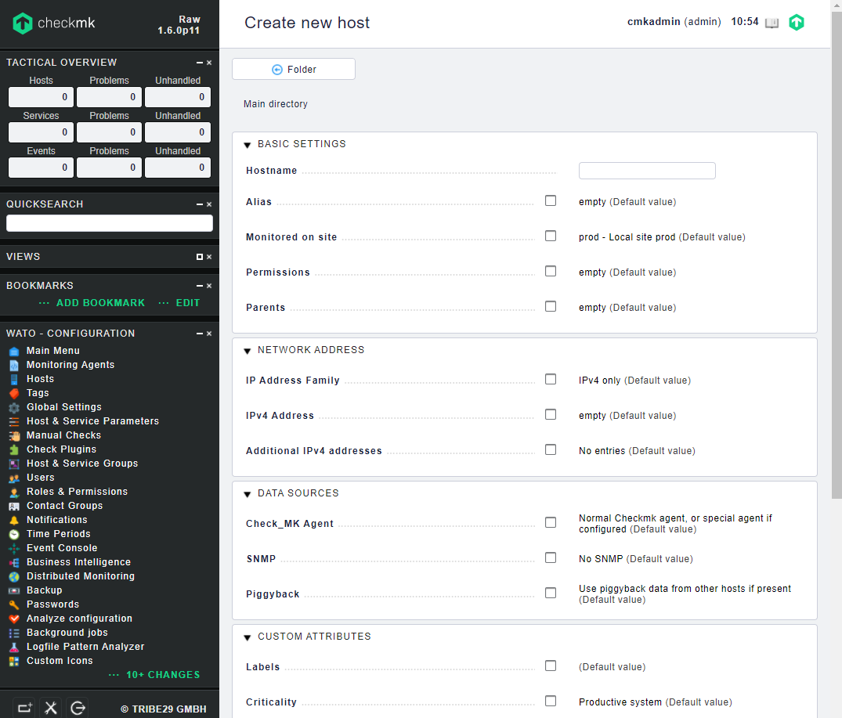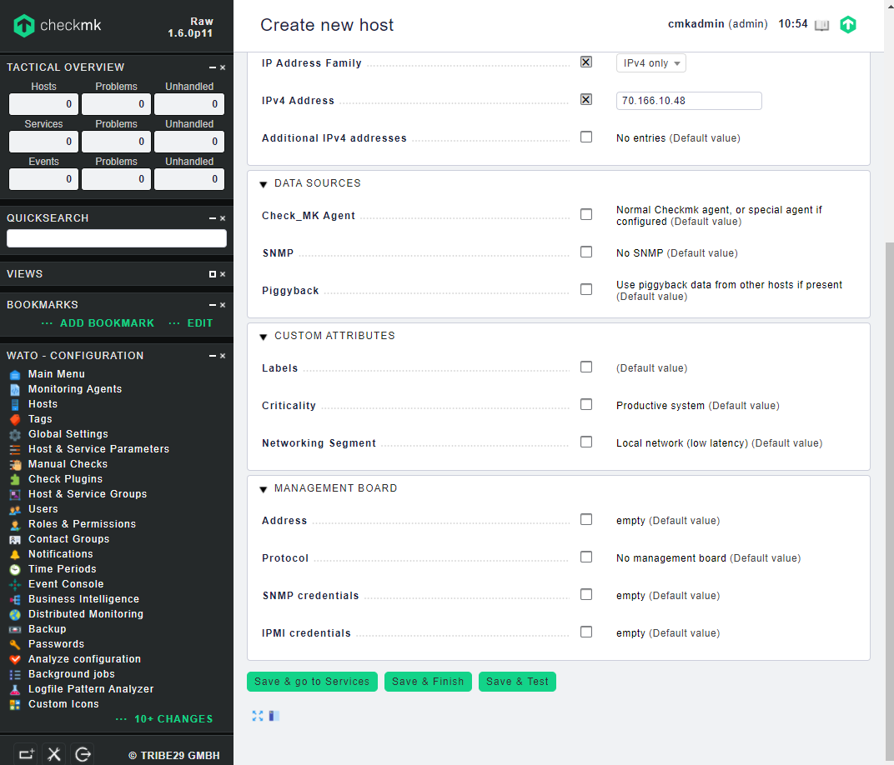

Set server parameters.

Click on the right of a parameter. When is displayed, you can set the parameter.



* In the **BASIC SETTINGS** area, set **Hostname**.
* In the **NETWORK ADDRESS** area, set the IP address information.
* In the **DATA SOURCES** area, set **SNMP** and **SNMP Credential** based on the actual SNMP version of the server.

Other parameters do not need to be set.

After the settings, click **Save & Finish**.

The **Main directory** page is displayed, showing the added server, as shown in Figure 3-5.

Main directory page

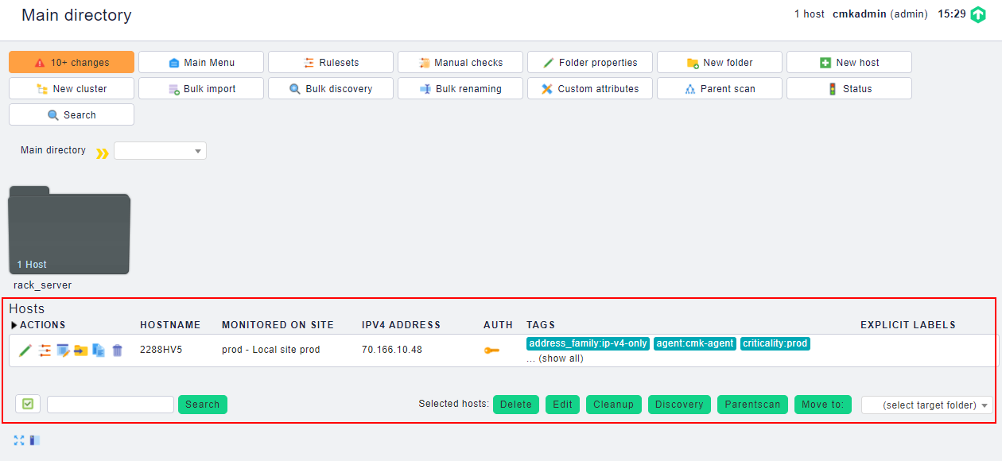

----End

### Adding a Huawei Server in Folder Mode

On the menu bar on the left, click **WATO - CONFIGURATION** > **Hosts**.

The **Main directory** page is displayed, as shown in Figure 3-6.

Main directory page



Click **New folder**.

The **Create new folder** page is displayed, as shown in Figure 3-7.

Create new folder

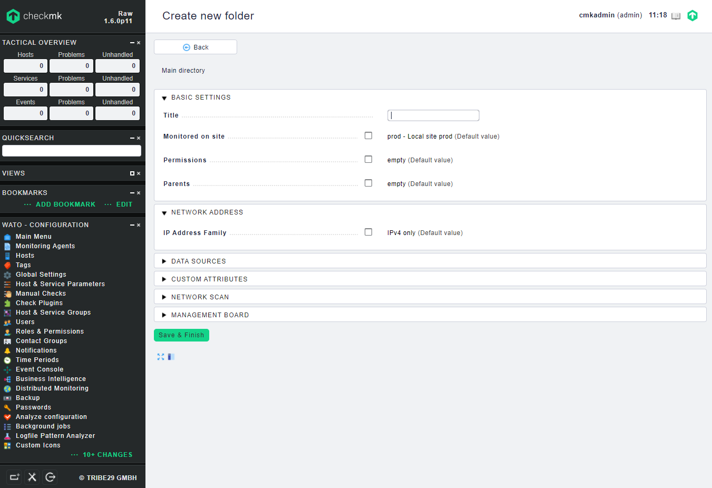

In the **BASIC SETTINGS** area, set **Title**, enter the folder name, and click **Save & Finish**.

The **Main directory** page is displayed, as shown in Figure 3-8. You can view the new folder.

Main directory

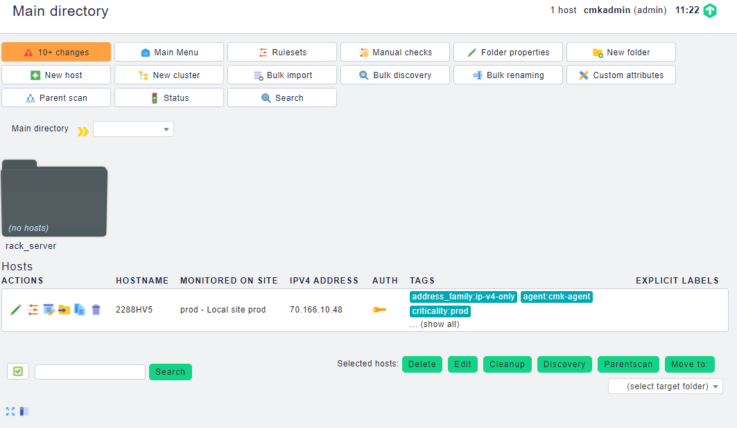

Click the folder created in Step 3.

The folder information page is displayed, as shown in Figure 3-9.

Folder information page

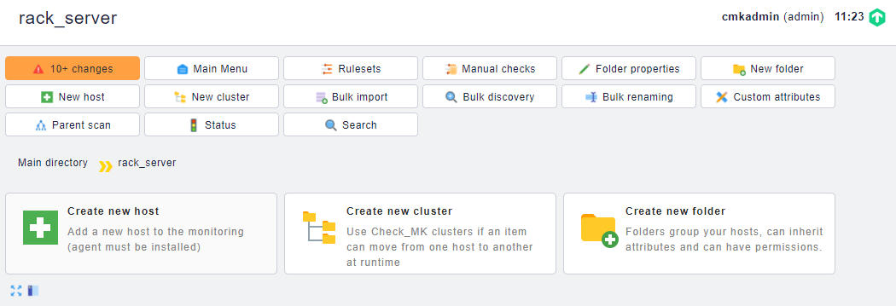

Click **New host**.

The **Create new host** page is displayed, as shown in Figure 3-10.

Create new host

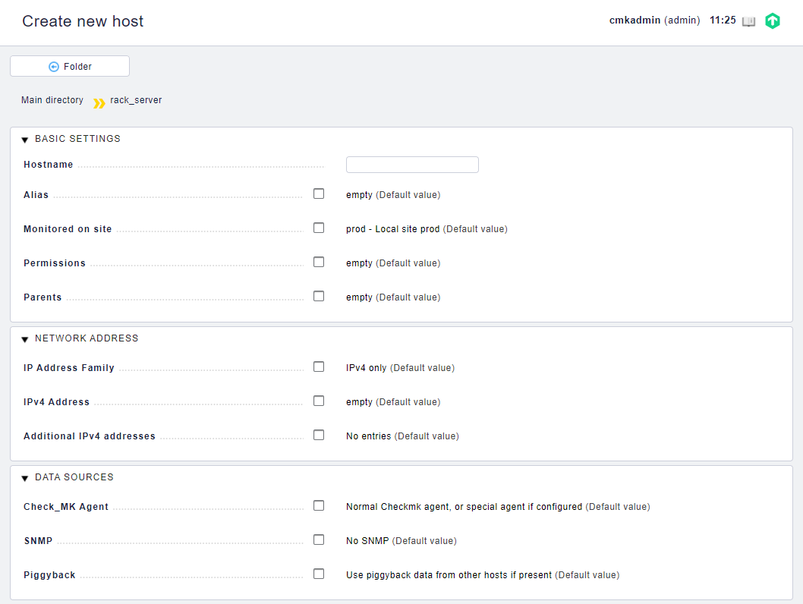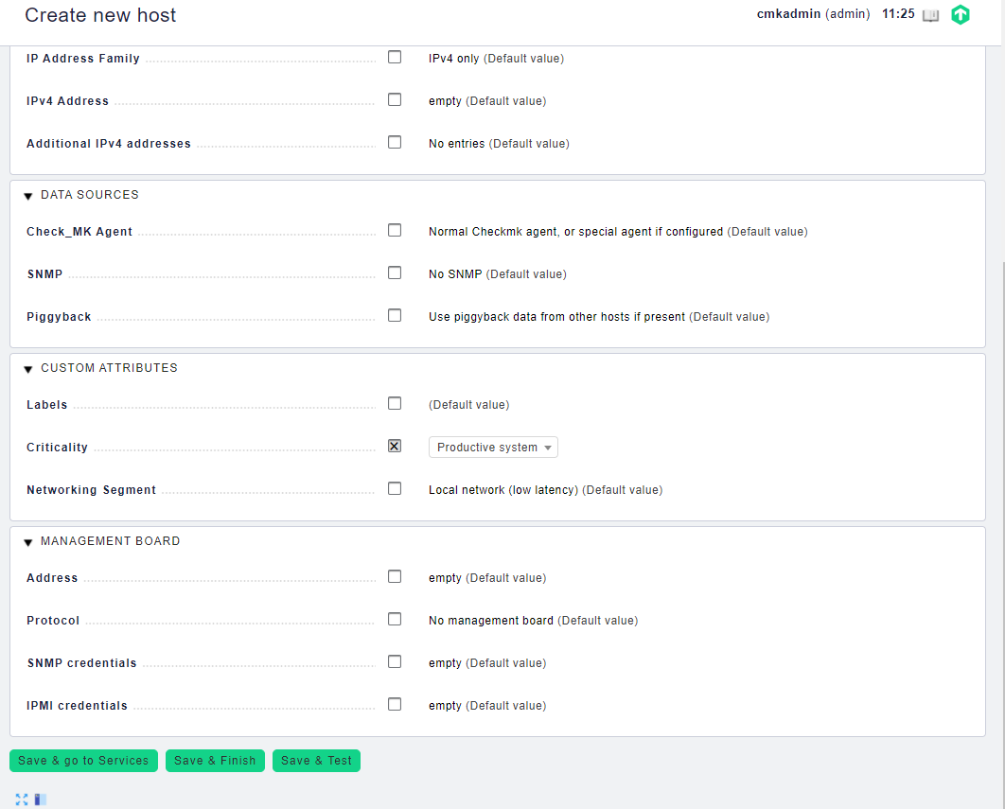

Set server parameters.

Click on the right of a parameter. When is displayed, you can set the parameter.



* In the **BASIC SETTINGS** area, set **Hostname**.
* In the **NETWORK ADDRESS** area, set the IP address information.
* In the **DATA SOURCES** area, set **SNMP** and **SNMP Credential** based on the actual SNMP version of the server.

Other parameters do not need to be set.

After the settings, click **Save & Finish**.

The folder information page is displayed, showing the added server, as shown in Figure 3-11.

Folder information page

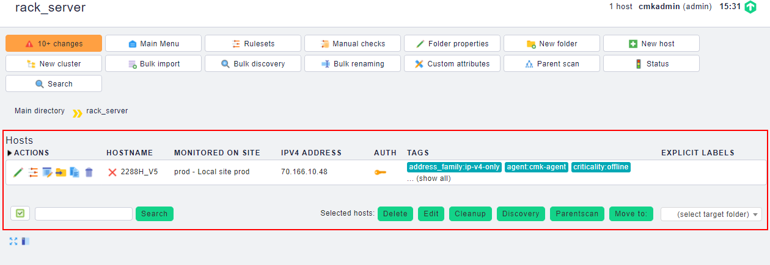

----End

## Editing a Huawei Server

### Editing a Directly Added Huawei Server

On the menu bar on the left, click **WATO - CONFIGURATION** > **Hosts**.

The **Main directory** page is displayed, as shown in Figure 3-12.

Main directory page

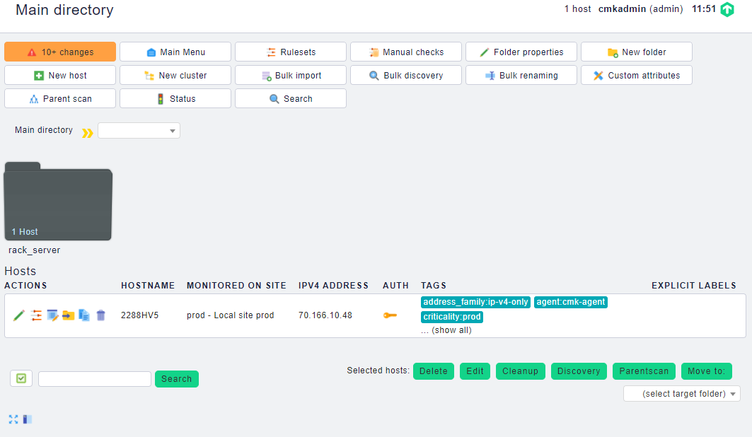

Click in the row that contains the server to be edited, as shown in Figure 3-13.



Editing a server

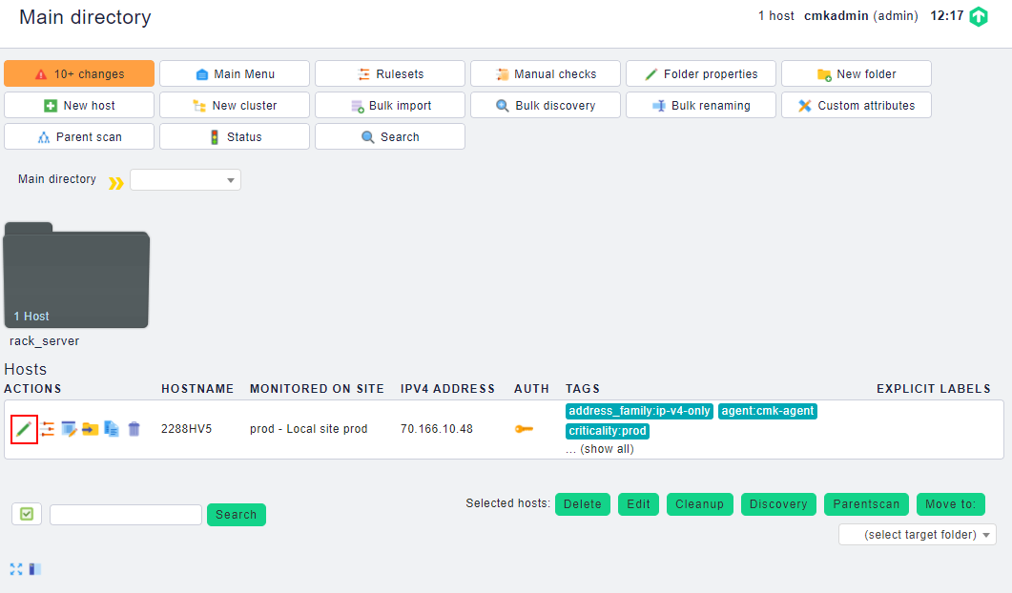

The page for setting the server is displayed, as shown in Figure 3-14.

Setting the server

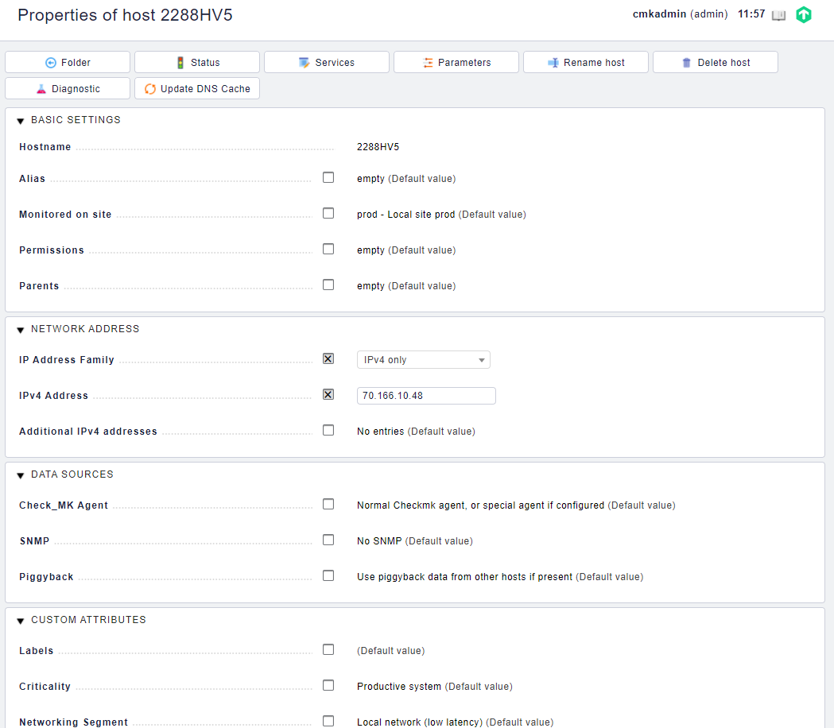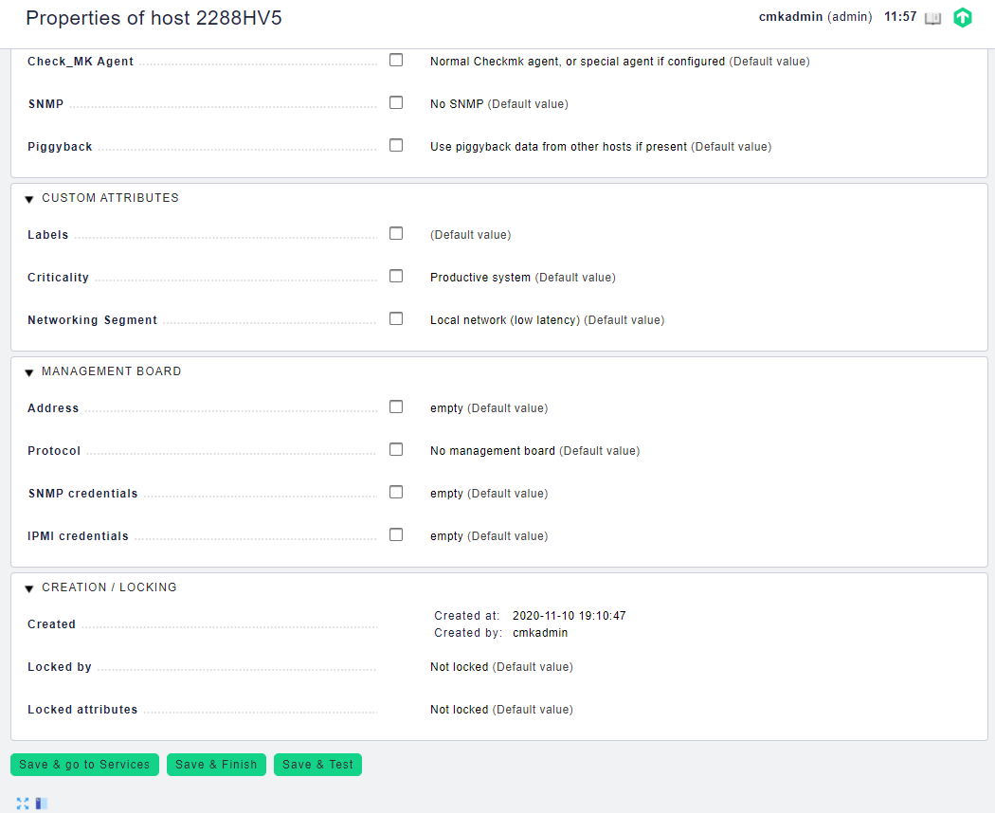

Modify server parameters as required and click **Save & Finish**.

The **Main directory** page is displayed.



The value of **Hostname** cannot be changed.

----End

### Editing a Huawei Server That Is Added in Folder Mode

Editing a Huawei Server

On the menu bar on the left, click **WATO - CONFIGURATION** > **Hosts**.

The **Main directory** page is displayed, as shown in Figure 3-15.

Main directory page



Click the folder where the server is located, for example, **rack_server**.

The folder information page is displayed, as shown in Figure 3-16.

Folder information page

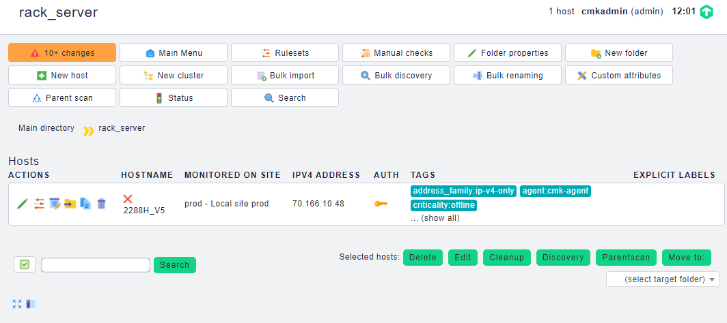

Click in the row that contains the server to be edited.



The page for setting the server is displayed, as shown in Figure 3-17.

Setting the server

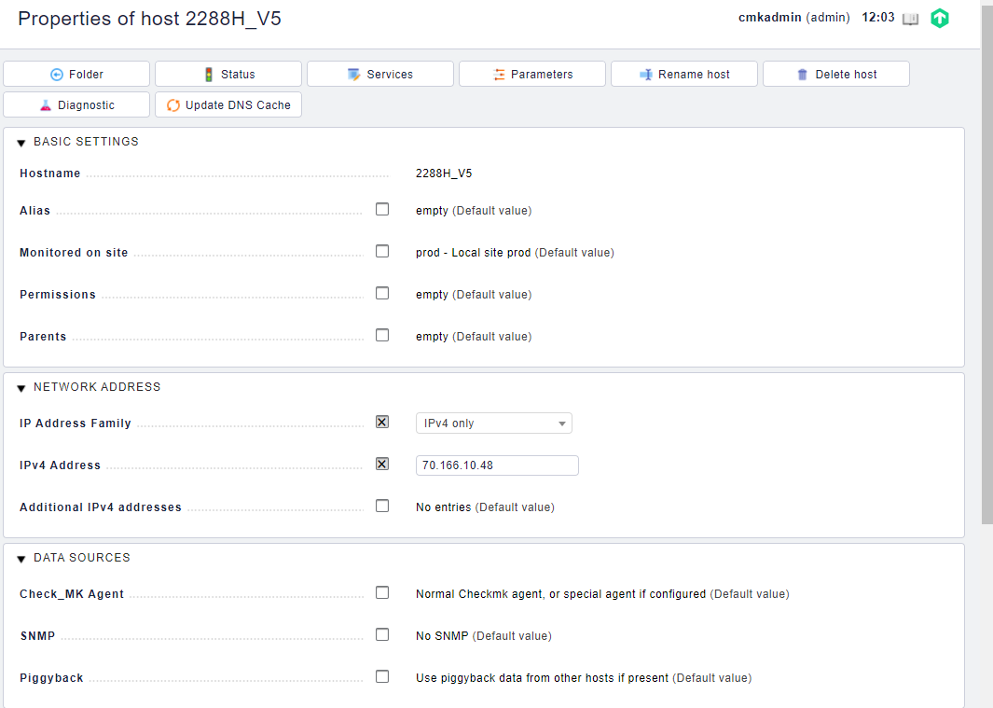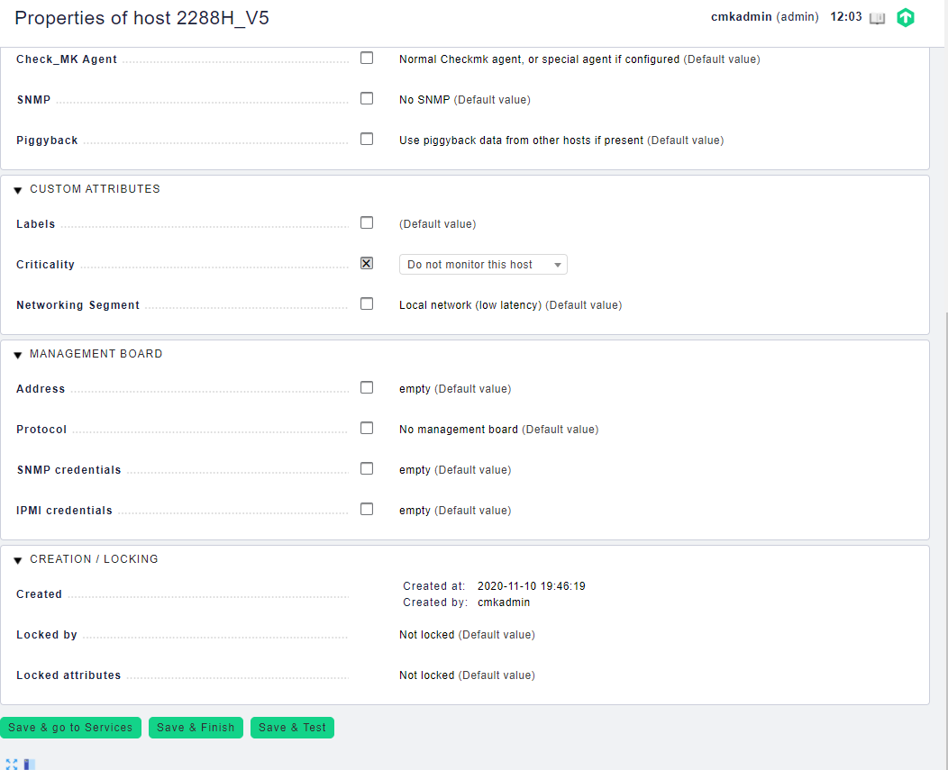

Modify server parameters as required and click **Save & Finish**.

The **Main directory** page is displayed.



The value of **Hostname** cannot be changed.

----End

## Deleting a Huawei Server

### Deleting a Directly Added Huawei Server

On the menu bar on the left, click **WATO - CONFIGURATION** > **Hosts**.

The **Main directory** page is displayed, as shown in Figure 3-18.

Main directory page



Click in the row that contains the server to be deleted, as shown in Figure 3-19.



Deleting a server

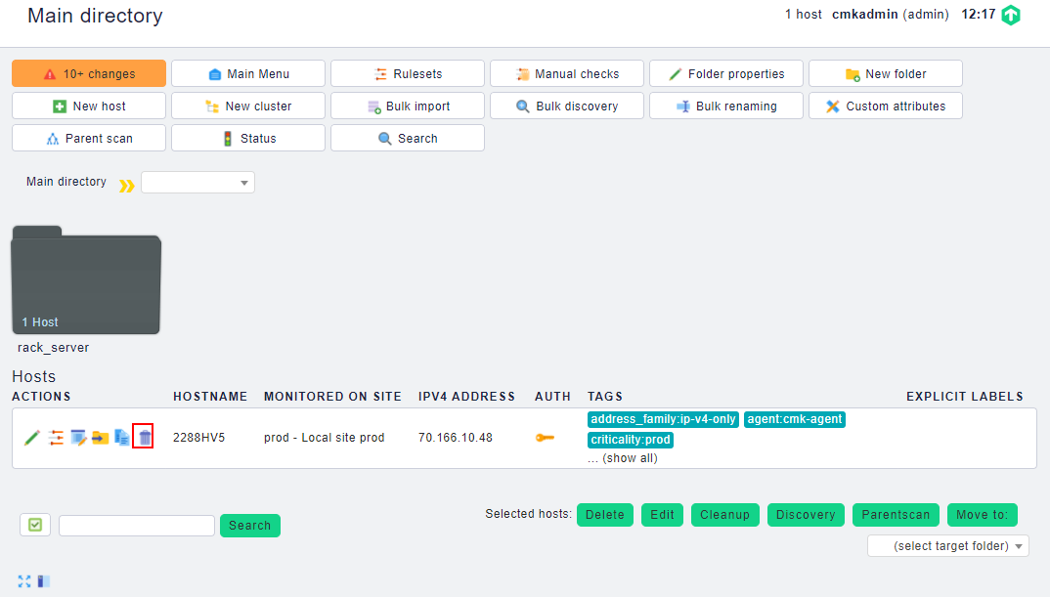

A deletion confirmation dialog box is displayed, as shown in Figure 3-20.

Deletion confirmation dialog box

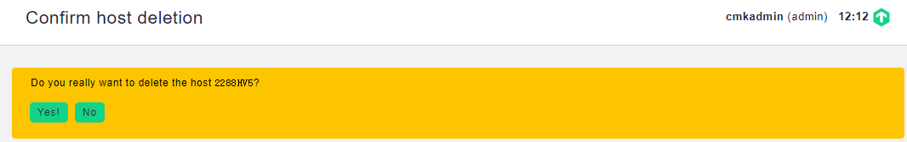

Click **Yes!**.

The server is deleted.



On the **Main directory** page, click to delete all added servers.



----End

### Deleting a Huawei Server That Is Added in Folder Mode

On the menu bar on the left, click **WATO - CONFIGURATION** > **Hosts**.

The **Main directory** page is displayed, as shown in Figure 3-21.

Main directory page



Click the folder where the server is located, for example, **rack_server**.

The folder information page is displayed, as shown in Figure 3-22.

Folder information page



Click in the row that contains the server to be deleted.



A deletion confirmation dialog box is displayed, as shown in Figure 3-23.

Deletion confirmation dialog box

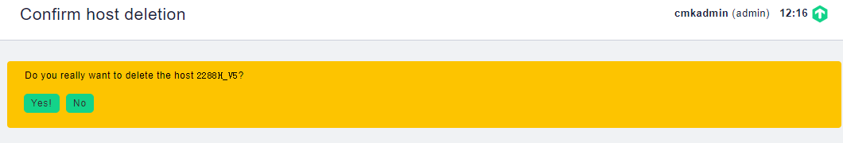

Click **Yes!**.

The server is deleted.



On the folder information page, click to delete all added servers.



----End

# Viewing Huawei Server Information

4.1 Viewing Information of a Directly Added Huawei Server

4.2 Viewing Information of a Huawei Server That Is Added in Folder Mode

## Viewing Information of a Directly Added Huawei Server

On the menu bar on the left, click **WATO - CONFIGURATION** > **Hosts**.

The **Main directory** page is displayed, as shown in Figure 4-1.

Main directory page

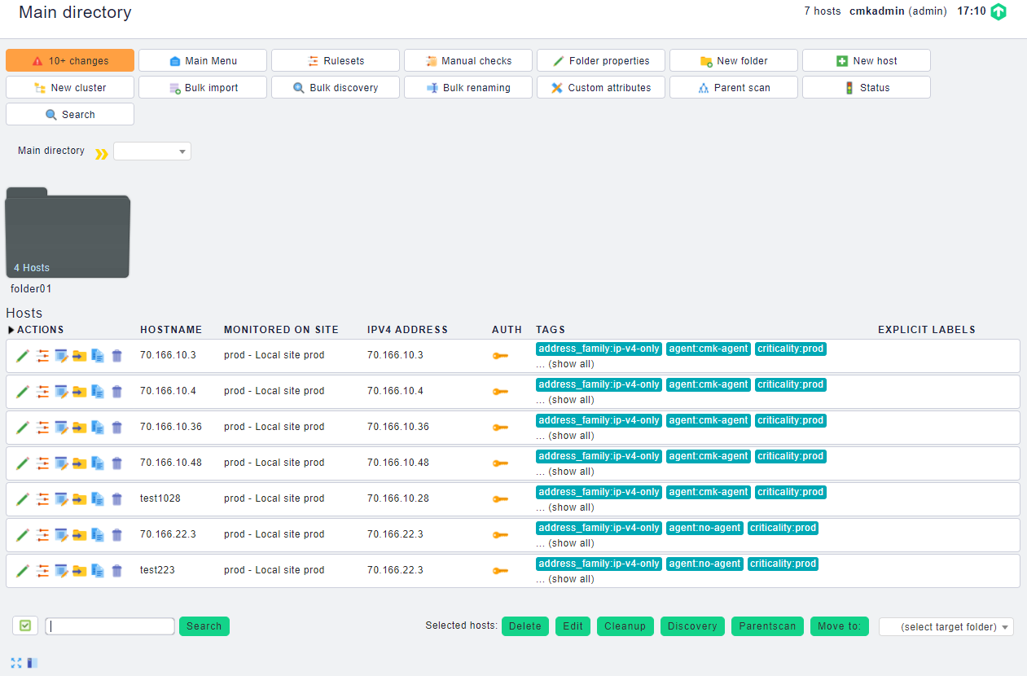

Click in the row that contains the server to be viewed, as shown in Figure 4-2.



Viewing server information

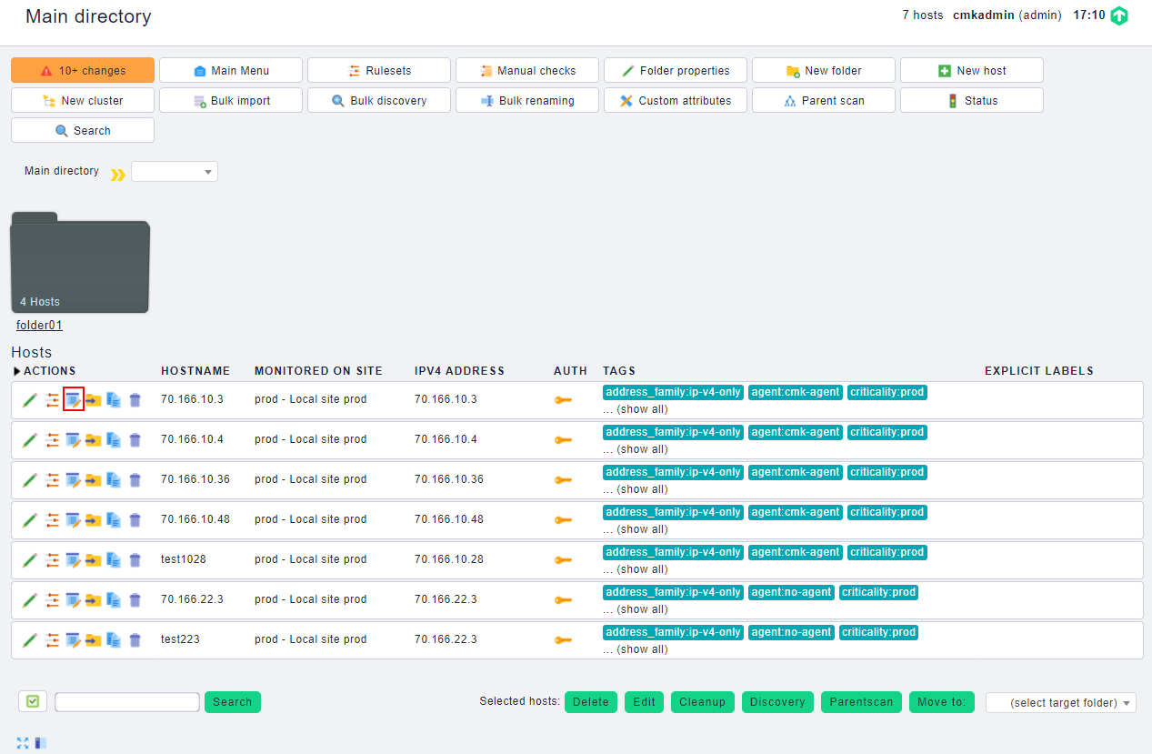

The server information page is displayed, as shown in Figure 4-3.

Server information page

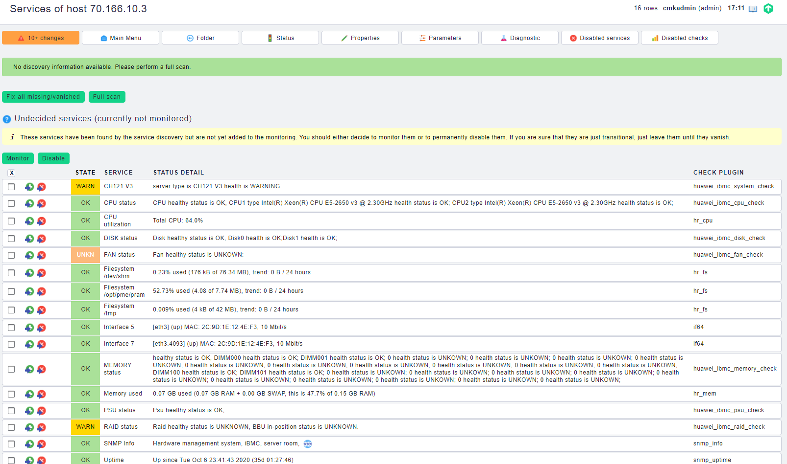

View the server information.

On this page, you can view the alarm information, component information, and component status of the server. The supported components include the CPU, fan, drive, memory, PSU, and RAID controller card. The line where **WARN** is located indicates the alarm information of the server.

----End

## Viewing Information of a Huawei Server That Is Added in Folder Mode

On the menu bar on the left, click **WATO - CONFIGURATION** > **Hosts**.

The **Main directory** page is displayed, as shown in Figure 4-4.

Main directory page



Click the folder where the server is located, for example, **folder01**.

The folder information page is displayed, as shown in Figure 4-5.

Folder information page

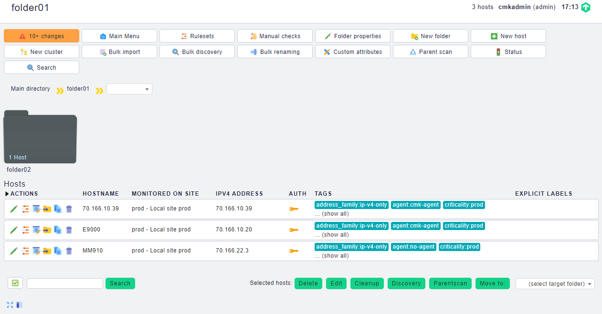

Click in the row that contains the server to be viewed, as shown in Figure 4-6.



Viewing server information

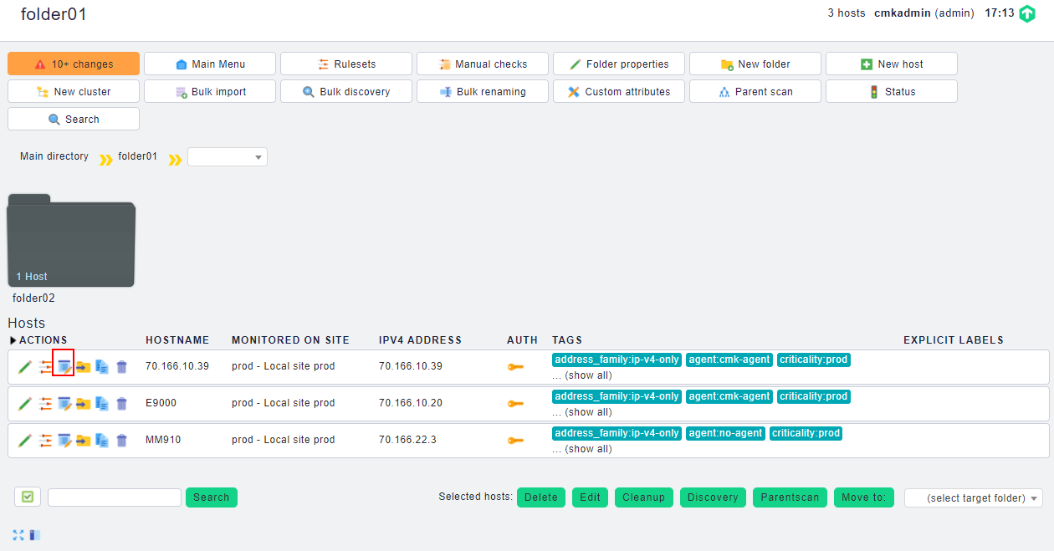

The server information page is displayed, as shown in Figure 4-7.

Server information page

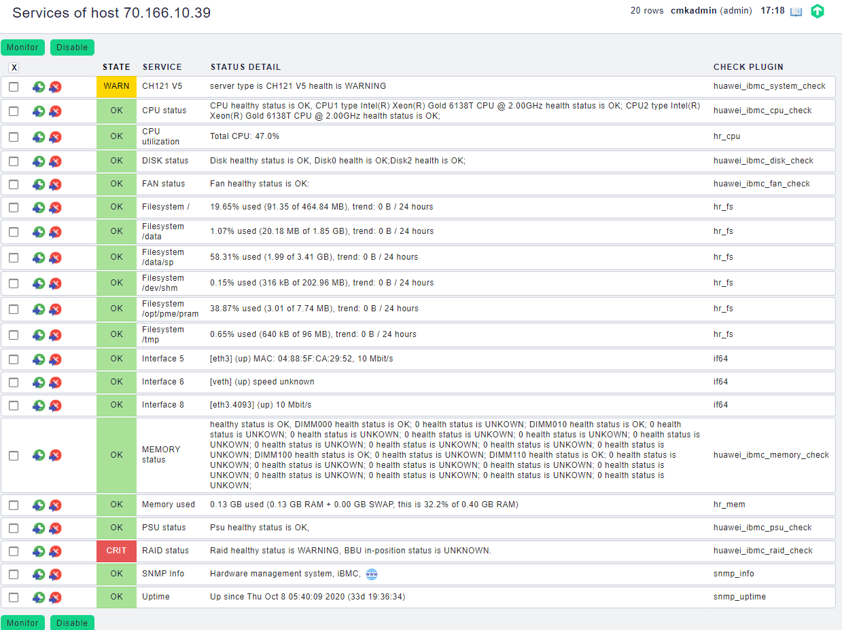

View the server information.

On this page, you can view the alarm information, component information, and component status of the server. The supported components include the CPU, fan, drive, memory, PSU, and RAID controller card. The line where **WARN** is located indicates the alarm information of the server.

----End

# FAQ

5.1 Connection Timeout Is Displayed When You Click Full scan During HMM Monitoring

## Connection Timeout Is Displayed When You Click Full scan During HMM Monitoring

Symptom

When you click **Full scan** during HMM monitoring, a message is displayed indicating that the connection times out, as shown in the following figure.

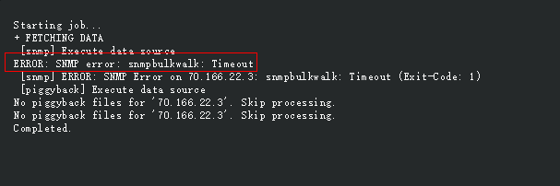

Solution

Check each blade node, find the subnode whose SNMP connection is abnormal, and delete the corresponding node scanning script **huawei_hmm_mezzX_check.py** (X indicates the slot number of the node) in the **/opt/omd/sites/prod/local/share/check_mk/checks/** directory.

1. Getting Help

If you encounter any problems during routine maintenance or troubleshooting, contact Huawei technical support engineers.

* 1. Collecting Fault Information

Before troubleshooting, obtain the following information:

* Customer company and address
* Contact person and telephone number
* Time when the fault occurred
* Detailed fault symptom
* Device type and software version
* Any measures taken and effects
* Fault severity and expected rectification deadline
  1. Preparing for Debugging

When you seek Huawei technical support, Huawei technical support engineers may assist you in performing some operations to further collect fault information or rectify the fault.

Before contacting technical support engineers, prepare the spare parts for boards and port modules, screwdrivers, screws, serial cables, and network cables.

* 1. Using Product Documentation

Huawei provides the documents delivered with the equipment. This document provides guidance for you to solve common problems that occur during routine maintenance or troubleshooting.

To better rectify the fault, you are advised to use the guide before contacting Huawei technical support engineers.

* 1. Obtaining Technical Support

Huawei's timely and efficient response is available from:

* Local branch offices
* Secondary technical support system
* Telephone support
* Remote support
* Onsite support

Technical Support Website

Obtain technical documents at [Huawei Technical Support](https://support.huawei.com/enterprise/en/index.html) website.

Self-Service Platform and Community

Learn more about servers and communicate with experts at:

* [Computing Product Information Service Platform](https://support-it.huawei.com/server/#/home) for specific server product documentation.
* [Huawei Enterprise iKnow](https://support.huawei.com/iknow/?source=SupportE) for quick learning about products.
* [Huawei Enterprise Support Community (Servers)](https://forum.huawei.com/enterprise/en/Server/forum/895) for learning and discussion.

News

For notices about product life cycles, warnings, and updates, visit [Support > Bulletins > Product Bulletins](https://support.huawei.com/enterprise/en/bulletins-product).

Cases

Learn about server applications at [Computing Case Library](https://support-it.huawei.com/server-knowledgebase/#/home).



The Computing Case Library is available only to Huawei partners and Huawei engineers.

Huawei Technical Support

If a fault persists after taking the above measures, obtain technical support in the following ways:

* Contact Huawei customer service center.
* Enterprise customers

Send emails to [support_e@huawei.com](mailto:support_e@huawei.com) or visit [Global Service Hotline](https://e.huawei.com/en/service-hotline-query).

* Carriers

Send emails to [support@huawei.com](mailto:support@huawei.com) or visit [Global TAC Information](https://support.huawei.com/carrier/docview!docview?nid=IN0000034614).

* Contact technical support at your local Huawei office.